September 21, 2025
Project – 2
Classification Models
By- Anadi Ranjan (PGPM009)

Business Problem: Bank ABC faces the challenge of customer churn, where clients close accounts or stop using services. This churn impacts revenue as acquiring new customers is more costly than retaining existing ones. Predicting which customers may leave allows Bank ABC to take proactive actions to reduce churn and maintain loyal customers, supporting sustained business growth.
Business Objective
Develop a classification model that accurately predicts customer churn using historical customer data. The goal is to identify customers likely to leave the bank so that targeted retention strategies can be applied to the high-risk group, ultimately minimizing churn and improving customer lifetime value.
Dependent variable-
- Exited- categorical (Yes/No)
Independent Variables -
- Credit Score: Continuous
- Geography: Categorical variable for customer location
- Gender: Categorical
- Age: Continuous
- Tenure: Continuous (years)
- Balance: Continuous
- NumOfProducts: Continuous
- HasCrCard: Categorical (Yes/No)
- IsActiveMember: Categorical (Yes/No)
- EstimatedSalary: Continuous

Classification using Logistic Regression, Decision Tree, Random Forest and Naive Bayes.
Model | AUC
Logistic Regression | 0.69
Decision Tree | 0.54
Random Forest | 0.65
Naïve Bayes | 0.56

Here, Logistic Regression has the highest AUC, so will take Logistic regression model and will find the threshold points to maximize the true positive. So that what is the criteria that customers are exiting the bank.
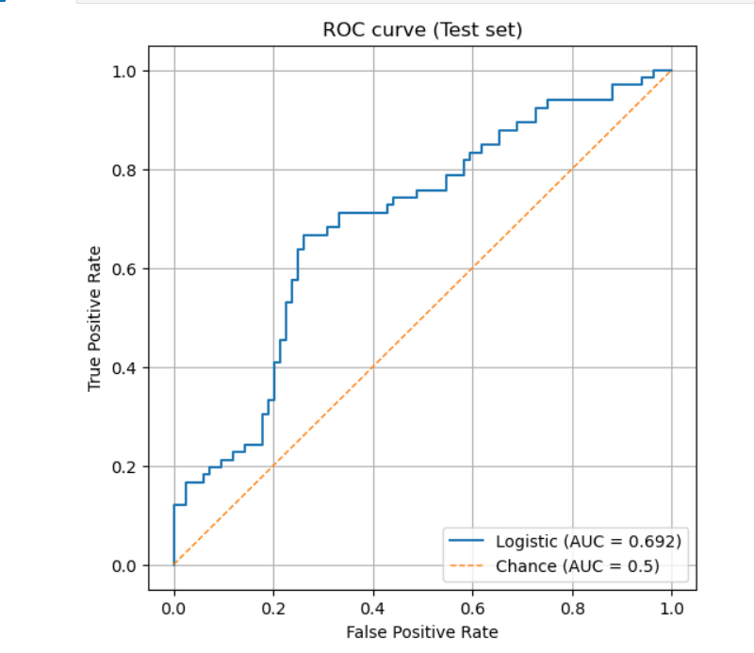
Inflection points and best threshold
Number of inflection points: 61
Thresholds at inflection points: [ inf 0.83323237 0.72205173 0.71226442 0.6802237 0.65994433 0.65635064 0.65497651 0.64844863 0.63693531 0.63352304 0.6267571
0.62207301 0.61663831 0.61442599 0.60403368 0.59217976 0.59217126
0.58891126 0.58209457 0.55319829 0.55314433 0.54306035 0.53534333
0.51905696 0.50134692 0.49415312 0.48005977 0.4663075 0.46238721
0.45516178 0.4413002 0.44055593 0.43889296 0.43215335 0.40646285
0.40164167 0.39289745 0.38558429 0.37847026 0.37755883 0.36709559
0.36486994 0.35008898 0.34633675 0.33722545 0.33297609 0.32647639
0.3249632 0.30043664 0.28283213 0.26771108 0.2675721 0.25708269
0.25020314 0.24551978 0.24533611 0.21051222 0.19199388 0.17229684
0.16428616]
Optimal Threshold: 0.455
Confusion Matrix at Optimal Threshold:
[[62 22]
[22 44]]
Accuracy at Optimal Threshold: 0.71
Sensitivity at Optimal Threshold: 0.67
- The threshold at 0.445 gave the best balance between correctly identifying positive cases and correctly ruling out negative ones. This threshold achieved the highest accuracy of 71%, showing that using this cutoff makes the model more reliable for predicting outcomes with fewer errors.

Predictors Importance
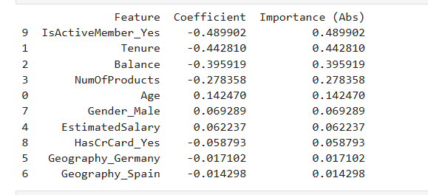
- IsActiveMember_Yes (-0.49) –This means active members are less likely to churn. We can strengthen engagement programs to keep them active.

- Tenure (-0.44) - which means longer tenure reduces churn risk. We need to build loyalty programs to further increase customer tenure.

- Balance (-0.40) – Here, higher balance lowers churn. We should offer tailored financial products to encourage higher deposits.

- NumOfProducts (-0.28) – This means more products reduce churn. We can cross-sell additional products to deepen relationships.

- Age (+0.14) - Older customers show slightly higher churn. We can design age-specific retention campaigns.

- Gender_Male (+0.07) - Male customers are marginally more likely to churn. Create personalized offers targeting male customers.

- EstimatedSalary (+0.06) - Higher salary slightly increases churn. We can offer premium/wealth-focused services to retain this segment.

- HasCrCard_Yes (-0.06) – This indicates credit card holders churn less. We should promote credit card adoption as a stickiness factor.

- Geography_Germany (-0.02) - German customers churn a little less. We should maintain localized engagement efforts.

- Geography_Spain (-0.01) - Spanish customers churn slightly less. We should continue country-specific retention strategies.

Conclusion - From the analysis, we can say customers who are active members, use more products, and keep higher balances are less likely to leave. So, the bank should try to keep customers engaged, encourage them to use multiple products, and motivate them to maintain higher balances. Giving rewards to people who stay longer can also help in building loyalty. On the other hand, customers who are older, earn higher salaries, or are male seem a bit more likely to leave, so the bank should make special offers or services for them. Having a credit card reduces the chance of leaving, so promoting credit card usage is also a good idea. Lastly, the bank can focus on small country-specific campaigns to keep customers in different regions happy.

